Nuga and Akinbola NJSS 21 (2 ) 2011: 61 - 68

LAND USE/LAND COVER CHANGE DETECTION IN IKWUANO AREA, ABIA STATE NIGERIA USING LANDSAT DATA

Nuga, B.O.¹ and Akinbola G.E. ²

¹ Department of Crop & Soil Sciences, Faculty of Agriculture, University of Port Harcourt,
Rivers State, Nigeria.
² Department of Agronomy, University of Ibadan, Oyo State, Nigeria
babatundenuga@yahoo.co.uk

ABSTRACT

The use of remotely sensed data through Geographic Information System template for land use evaluation and classification is relatively cheap with less drudgery. Landsat satellite imageries covering Ikwuano area were acquired and processed with ERDAS Imagine. These were applied in mapping land use changes in Ikwuano Local Government Area of Abia State, Nigeria. Three major LULC types: forest land, agricultural land and built - up land were identified. Over the 14 year period, the quantitative analysis of the imageries showed that 10.2% of the total land area changed from forest land to agricultural land; 4.5% changed from forest land to built- up land; 10.9% from agricultural land to forest land. About, 18.1% of agricultural land remained unchanged; 9.9% of agricultural land changed to built - up land; 4.5% from built - up to forest; 9.4% from built - up to agricultural land. Anthropogenic factors were identified as playing a significant role in land cover change. A similar remote sensing approach could be used for monitoring temporal and spatial aspects of other regions as well as employed in the development of the natural resource database of the country.

INTRODUCTION

Land is about the most important endowment of Nigeria, providing livelihood in both the agricultural and non-agricultural sectors. Thus, the nation’s development is intricately tied to the efficient use and management of its land resources (Omoti, 1999). Nigeria's land area of about 924,000 km² supports about 150 million people (NPC, 2006). This population, which is rapidly growing at the rate of 3.5% per annum, has resulted in a great pressure on the land. More often than not, land use practices in Nigeria, do not take cognisance of the suitability of the land for the intended purpose. The increasing population in Nigeria and its
61

associated unplanned pressure on land has led to the indiscriminate use of land without much consideration for the short and long term effects on the environment. Usually, decisions on land use are made indiscriminately based mainly on economic and political considerations, with little or no consideration for the biophysical status of the soils (Nuga, 1998).

In the scenario of a rapidly expanding world population, changes in land use and declining forest cover, remote sensing has the role of an emerging discipline, and provides essential tool of trade to the field forester. (Howard, 1991). Land use change is altering human and natural systems globally and regionally (Solecki, 2001; Foley et al., 2005). Globally, nearly 1.2 million km² of forest and woodland and 5.6 million km² of grassland and pasture land have been converted to other uses, and over the last three (3) centuries, 12 million km² of cropland were lost (Rahamankutty and Foley, 1999). Conversion of natural landscapes to human dominated uses alters the availability of energy, water and nutrients to ecosystems, degrades soil and water, increases the spread of exotic species, reduces biodiversity, increases exploitation of species, accelerates natural processes of ecosystem change and adversely affects the structure and functioning of ecosystems (Adger and Brown, 1994; Ojima et al., 1994; Vitousek et al., 1997; Pimm and Riven, 2000). Knowledge of the dynamics and patterns of typical forest loss and fragmentation may be useful for answering questions related to long sustainability of human-forest interaction and for developing management policies that protect and enhance tropical forest (Fox et al., 1995).
Land use detection
This study was therefore carried out to identify major land use/land cover types in the area and its dynamics over a fourteen years period.

MATERIALS AND METHODS

Study Area
The study area is located in the South eastern region of Nigeria. It is one of the seventeen Local Government Areas making up Abia State. The area lies between latitudes 5° 20’ and 5° 30’N, longitudes 7° 28’ and 7° 42’E, with elevation ranging from 109 to 152m above mean sea level. The study area is bounded in the north by Umuahia LGA, in the south by Ikot-Ekpene, Akwa Ibom State, in the east by Bende LGA and in the west by Isiala Ngwa LGA.

Data Acquisition and Processing
Landsat Thematic Mapper (TM) and Enhanced Thematic Mapper (ETM +) images (with path 188 and row 056) acquired on December 19th, 1986 and December 17th, 2000 respectively, were employed in the land use/ land cover mapping. The original satellite images used for this project were Landsat TM (Thematic Mapper) from the Landsat home page http://www.landsat.org/ortho/index.htm. These images are representations of the available features and land covers over the particular area covered. The images consist of different bands and each band register wavelengths that are used for different purposes. Tables 1 and 2, shows the basic characteristics of Landsat TM images for the two different years considered for the study.

The satellite orbits was at an altitude of 705 km providing a 16-day, 233-0rbit cycle with a swath overlap that varies from 7 percent at the equator to nearly 84 percent at 81º North or South latitude. These satellites also were designed and operated to collect data over a 185-km swath. The TM sensor primarily detects reflected radiation from the earth’s surface in the visible and near- infrared (IR) wavelengths. The TM sensors have seven spectral bands. The wavelength range for the TM sensor is from visible, through the mid-IR, into the thermal-IR portion of the electro-magnetic spectrum.

The acquired images were processed using ERDAS IMAGINE 9.1 and ArcGIS 9 software. On the acquired images, water appeared deep blue, vegetation (forests and cultivated land) showed up in red and settlements and road showed up in shades of cyan.

Table 1: Different bands, wavelengths, colors main purpose and resolution of 1986 satellite
62
image.
Nuga and Akinbola NJSS/21(2)/2011
Band | Wavelengts | Colour | Main Purpose | Resolution
1 | 0.45 – 0.52 μm | Blue | Maximum penetration of  water, which is useful for  bathymetric mapping in  shallow water, useful for  distinguishing soil from  vegetation and deciduous  from coniferous plants | 30m
2 | 0.52-0.60 μm | Green | Matches green reflectance  peak of vegetation, which is  useful for assessing plant  vigor | 30m
3 | 0.63-0.69 μm | Red | Matches a chlorophyll  absorption band that is  important for discriminating  vegetation types | 30m
4 | 0.76-0.90 μm | NIR | Useful for determining  biomass content and for  mapping shorelines | 30m
5 | 1.55-1.75 μm | MIR | Indicates moisture content  of soil and vegetation.  Penetrates thin clouds, and  provides good contrast  between vegetation types. | 30m
6 | 10.40-12.50 μm | TIR | Nighttime images are useful  for thermal mapping and for  estimating soil moisture | 120m
7 | 2.08-2.35 μm | MIR | For mapping  hydrothermally altered  rocks associated with  mineral deposits. | 30m
Source: Note, NIR = Near Infrared, MIR = Mid Infrared, TIR = Thermal Infrared

The 2000 has two extra bands. These bands represent bands 6 and Table 2 shows the different bands, wavelengths, colors, main purpose and their resolution.

Table 2: Wavelengths, colors main purpose and resolution of bands 6 and 8, in satellite
image 2000
Band | Wavelengts | Colour | Main Purpose | Resolution
6 | 10.40-12.50 μm | TIR | Cloud detections | 60m
8 | 0.52-0.90 μm 15m | Panchromatic | Large area mapping  and urban change  studies | 15m
Source: Boggione et al., (2003)

Image Classification
63
Image classification is the process of sorting pixels into a finite number of individual classes or categories of data based on their data file values. If a pixel satisfies a certain set of criteria, then the pixel is assigned to the class that corresponds to those criteria.
Land use detection

In this study, the unsupervised classification was used, in which a thematic raster layer map was created by letting the software-ERDAS IMAGINE, identify statistical patterns in the data. The land use/land cover mapping was done by relying heavily on the differences of spectral characteristics of the landscape for seperation into meaningful land use and land cover classes. Multispectral reflectance data or remotely sensed imagery from satellite sensors serve as surrogate data representative of landscape feature or attributes.

A modified land – cover classification scheme that was consistent with the one developed by Anderson et al., (1976) was used as the classification scheme (Table 3). This same scheme has been used by Oyinloye et al., (2004) and Akinyemi (2005) for land cover classification in different parts of Nigeria. The modified scheme consists of three (3) classes with eleven (11) subclasses imbedded.

Table 3: Modified Anderson et al., (1976) Land cover classification scheme used for the study
Land Cover Class | Subclass
Built up/ Open land | Settlement
 | Residential/ office areas
 | Roads
 | Open land/ fields
 | Bare soil
Forest | Natural forest
 | Forest Plantaintion
 | Secondary regrowth
Cropland | Cultivated Field
 | Fallow land
 | Open bushland
 | Dense bushland

RESULTS AND DISCUSSION

The result of the changes in the surface area covered by each land cover type which were calculated between 1986 and 2000 is shown in Table 4. The change detection matrix is shown in Table 5 and the percentage change in one land cover to another in Table 5. It was discovered that Forest covered 18157.28 ha (37.41%) in 1986 and 18508.33 ha (38.13%) in 2000. Cropland/sparse vegetation was 18856.38 ha (38.86%) in 1986 but came down to 18292.44 ha (37.69%) in 2000. Built up/open land/roads increased from 11520.63 ha (23.73) in 1986 to 11733.52 ha (24.18%) in 2000.
64

The percentage changes in land cover over the period of study are shown in Table 6.Out of 18157.28 ha that was forest in 1986, 11037.02 was still forest in 2000 representing 60.79 % but 4932.47 ha (27.17%) was converted to cropland/sparse vegetation and 2187.80 ha (12.05%) to built up, open land/roads. At the same time, of the 18856.38 ha that was cropland in 1986, 5290.59 ha (28.06%) changed to forest; 8782.62 ha (46.58%) remain unchanged as cropland and 4783.18 ha (25.37%) was changed to built-up/open land /roads. Built-up/open land / roads covered an area of 11520.63ha in 1986. By 2000, 2180.73 ha (18.93%) were changed to forest; 4577.35 ha (39.73%) to cropland and 4762.55ha (41.34%) remain unchanged. The result in Table 4 showed that net increase in Forest cover was 351.05 ha (0.72% increase over 1986 by 2000). That of cropland, sparse vegetation decreased by 563.95 ha (-1.17% decrease). The built-up/open land/roads increased by 212.89 ha (0.45% increase) over the same period .
Nuga and Akinbola NJSS/21(2)/2011
Between 1986 and 2000, there had been significant land cover changes in the study area. The data showed a decline in area covered by cropland / sparse vegetation. As the population of the study area increased e.g. due to the establishment of a Federal University (Federal University of Agriculture, Umudike) in the area and a Federal Research Institute (National Root Crop Research Institute, Umudike), there was an influx of people to the area which necessitated the clearing of land for new dwelling places. The first to go were probably the croplands / farms near existing dwelling places. The deduction here is that as the local populace cleared more land in an attempt to accomodate the influx of people into the area . The loss in cropland as indicated in the results, most probably, was amplified by the fact that the time of image acquisition for the study falls within the dry season ( off season), in which case most crops have been harvested and a large percentage of the remaining crops have shed their leaves or taken up brownish colouration which has similar spectral tone to that of openland/roads/built up areas.

Table 4: Overall percentage/ Summation of Land use /Land cover Changes over 14 years
period.
LU/LC | 1986 | 2000 | Change (ha) | 1986 | 2000 | Change %
Area coverage
(%)
Forest | 18157.28 | 18508.33 | 351.05 | 37.41 | 38.13 | 0.72
Crop land/Sparse vegetation | 18856.38 | 18292.44 | -563.95 | 38.86 | 37.69 | -1.17
Built up/open land/roads | 11520.63 | 11733.52 | 212.89 | 23.73 | 24.18 | 0.45
Total land area | 48534.29 | 48534.29 |  | 100% | 100%

Table 5: Change Detection Matrix for the land use/ land cover analysis of Ikwuano LGA of

Nigeria.
Land use/ Land cover 2000 (Hectares)
Land use / land cover 1986 | Forest | Crop land/  Sparse vegetation | Built up/open land  /roads | Grand Total
Forest | 11037.02 | 4932.47 | 2187.80 | 18157.28
Crop land/Sparse vegetation | 5290.59 | 8782.62 | 4783.18 | 18856.38
Built up/open land/roads | 2180.73 | 4577.35 | 4762.55 | 11520.63
Grand Total | 18508.33 | 18292.44 | 11733.52 | 48534.29

Table 6: Percentage Change in land use/ land cover of Ikwuano LGA of Nigeria betweeen

1986 and 2000.
Percentage change in land cover between 1986 and 2000 ( % )
Land use/land cover | Forest | Crop land/  Sparse vegetation | Built up/open land  /roads | Grand Total
Forest | 60.79 | 27.17 | 12.05 | 100
Crop land/Sparse vegetation | 28.06 | 46.58 | 25.37 | 100
Built up/open land/roads | 18.93  65 | 39.73 | 41.34 | 100
Land use detection

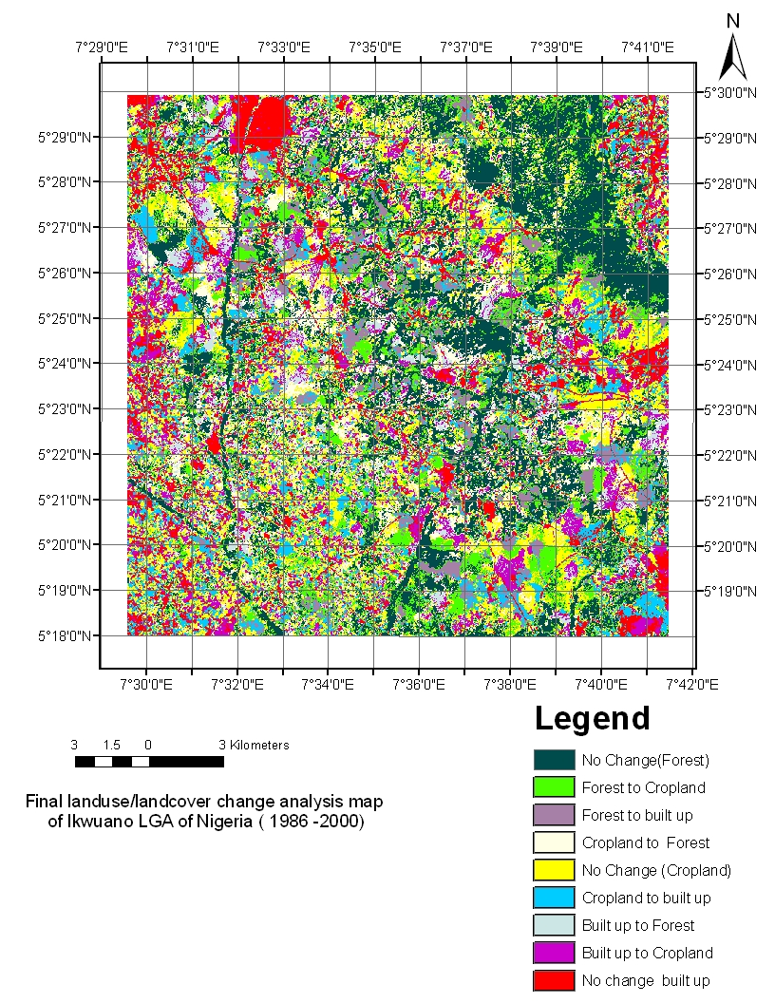

Fig 1: Land use / land cover change analysis map of

Ikwuano LGA of Nigeria (1986-2000).
66
Nuga and Akinbola NJSS/21(2)/2011
The area of forest lost was gained by the transformation of some cropland/ sparse vegetation to forest (probably secondary fallow). This could have been through the fallow system (of between 2-3years) which is a common practice in the area. Also a number of homes had fruit trees planted around it and this would have formed closed canopies within the study period to qualify them as forest cover. Another possibility for the seeming gain by forest would have been spectral reflectance of cassava plant which was the major crop on the field at the time of the year when the data were captured and also observed during the ground truthing exercise.

Land use/land cover change in the study area was initiated with the clearing of forest and cropland through slash and burn techniques commonly followed by the planting of annual crops and in some cases, fields are kept in cultivation continuosly. The typical nature of change is one from undisturbed forest to a landscape cleared for crop production, with a significant component of secondary regrowth on abadoned land which in a number of cases are further exploited as fuel wood. The change in forest and cropland covers is also driven by the land clearing pattern of farmers in which case farmers tend to clear more land than they can manage at the outset, which later drop as farmers realize the high cost of management. The replacement of natural vegetation by agriculture (or replacement of vegetative cover) land/open surfaces will increase the land surface albedo which will accentuate the magnitude and duration of drought. Exposing fragile soils to long periods of insolation lead to accelerated erosion.

In addition, a number of land use practices physically observed in the study area such as annual bush burning, quarrying, farming on steep slopes, are not best management practices for the landscape. It leads to soil erosion which subsequently become a major contributor to non-point source pollution in the hydrology of the area and other forms of land degradation.
67
Nonetheless, no single factor may be attributed to be responsible for the land cover changes; instead the dynamics of land cover is a response to many variables relating to the local economy, institution and land tenure system.

CONCLUSION

The results of this study revealed the land cover change in the study area over 14 years-time period. The result can be employed in modelling land use /land cover change and it will go a long way in assisting such environmental tasks as land use planning, policy formulations, maintenance of land resources and environmental research and monitoring. There will therefore, be a reduction in uncertainty in the selection of land use strategies since decision makers will have a complete picture of the likely impact of alternative agricultural uses of land before changes are implemented.

REFERENCES

Adger, W.N. & Brown, K. (1999). Land Use & the Causes of Global Warming. Wiley New York.

Akinyemi, F.O. (2005). Mapping Land Use
dynamics at a regional scale in Southwestern Nigeria. “High-Resolution Earth Imaging for Geospatial Information” Inter. Archives of Photogrammetry, Remote Sensing & Spatial Information Sciences (IAPRsSIS), Hannover, Germany pdf. Retrieved Sept.18, 2006 from http:// www.ipi.uni hannover.de/html/publikationen/2005/workshop/149-akinyemi.

Anderson, J.R., Hardy, E.E., Roch, J.T. and
Witmer, R.E. (1976). A land use and land cover classification system for use with remote sensor data. Geological survey professional paper. 964. Washinghton. United States Govt. Printing office.
Land use detection
Foley, J.A., Defries, R. and Asner, G.P.
(2005). Global consequences of land use changes. Science,309, 570-574.

Fox, J., Kanter, R.,Yarnasain, S., Ekasingh, M
and Jones, R. (1995). Farmer decision making and spatial variable in Northern Thailand. Environmental Management, 18: 391 -399.

Howard, J.A. (1991). Remote Sensing of
Forest Resources. Theory and Application. Chapman and Hall publisher. London.)

Nuga, B.O. (1998). Characterization and
Classification of Ajibode soils. Unpub. M.Sc thesis. Dept. of Agronomy. University of Ibadan.72pp.

Ojima, D.A. Galvin, K.A. and Jurner, B.L.
(1994). The global impact of Land Use change Biosciences 4, 300-304.

Omoti, U. (1999). Welcome Address –
Proceedings of the 25th Annual Conference of the Soil Sci. Soc. of Nig. 21-25th, Nov. 1999. 272pp.

68

Oyinloye, R.O.., Agbo, B. F. and Aliyu, Z.O.
(2004). Land use/Land cover mapping in Osun State using Nigeria SAT-1 data. Retrieved on 13th April, 2005 from www.narsda.gov. ng/docs/gueye/pdf.

Pimm, S.L. and Riven, P. (2000). Biodiversity: Extinction by numbers. Nature 403:843-845.

Rammankuty, N. and Foley, J.A. (1999).
Estimating historical changes in global land over: Croplands from 1700 – 19992. Global Biogeochemical cycles. 13 : 997 – 1027.

Solecki, W.D. (2001). The roles of global to
local linkages in land use/ land cover changes in South Florida. Ecological Economics 37, 339-356.

Vitousek, P.M., Mooney, H.A., Lubchrenco, J.
and Melillo, J. M. (1997). Human domination of the Earth’s ecosystems. Science 277: 494-499.

